1. **Agenda**: Let’s see container’s life cycle.
2. 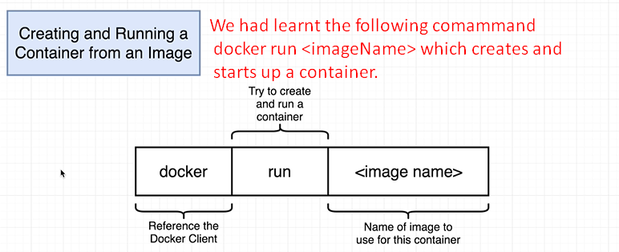
3. Creating a container and starting it up are two separate processes.
4. 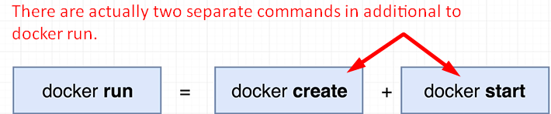
5. 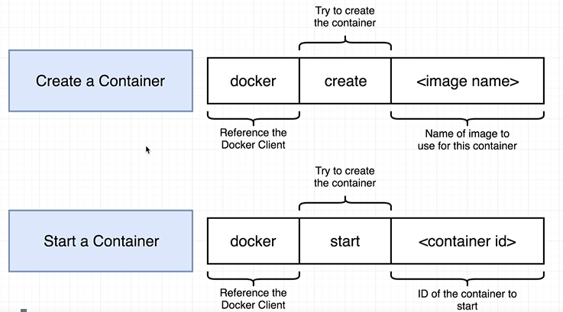
6. 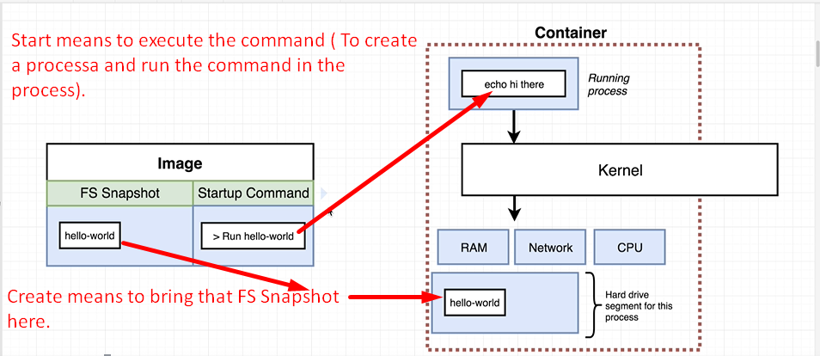
7. Let’s investigate that with command line.
8. **Command**🡺 docker create Hello-world  
   
9. **Command** 🡺 docker start –a <above_container_id>  
   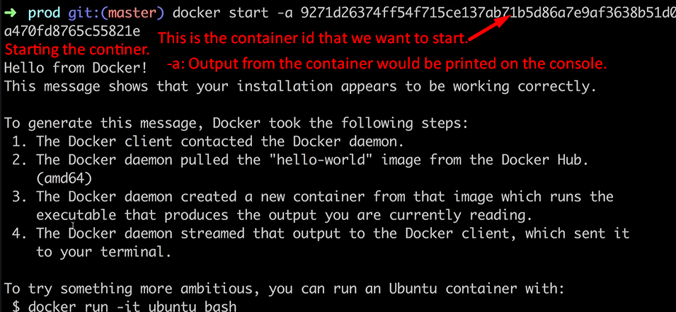
10. **NOTE:** Docker run shows you all the logs or all the info coming out of the container by default but docker start command is opposite.